Parsec Airfoil Parameterization

* 12 variables are taken into account (or 11 if you use LE radius for both upper and lower)

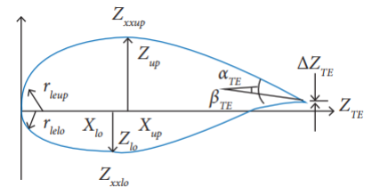

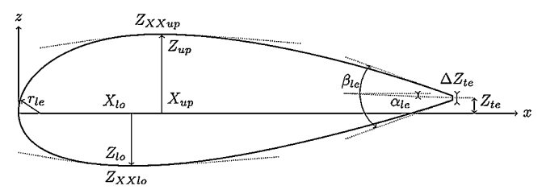

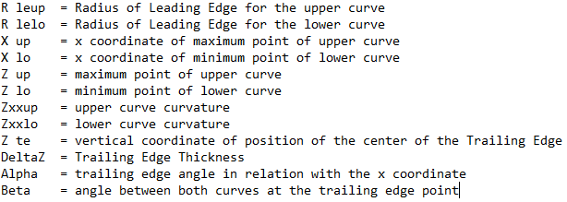

**The main thing about the airfoil’s upper and lower curve is that they are each represented by a polynomial function**, functions (represented as zup and zlo) that can be obtained by solving linear systems with parameters based on the 12 initial variables.

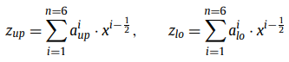

OBJECTIVE: Discover the coefficient ai (for i = 1,2,3,4,5,6) based on the 12 variables



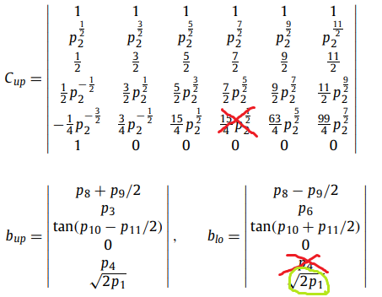

These are the systems (differenciate the expression right above the first X to get the right result), (the second X should be p7), (if you want to use 2 different rle, change the value of p1 on the second expression to another value, so that p1 will be the rleup and the new value will be rlelo) based on the following table:

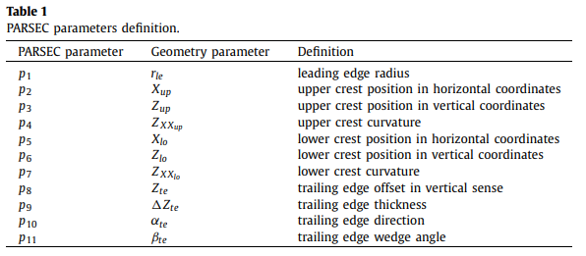

The systems follow the rules:

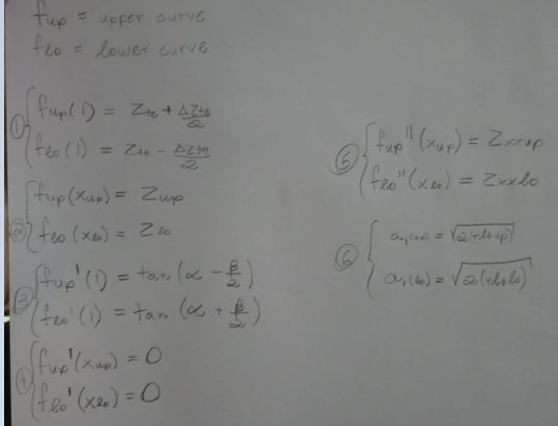

When you discover the distribution function (zup or zlo), you can take as many points as you like.